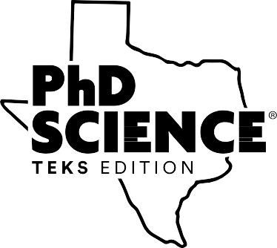
Curriculum Foundations of
PhD Science® TEKS Edition
Participant Handout
160.01.01P

[page intentionally left blank]
2020
Copyright © Great Minds PBC


Curriculum Foundations of PhD Science® TEKS Edition
Knowledge Building
Use the space below to elaborate on this curriculum pillar.
Notice and Wonder
Anchor Visuals
Anchor Model
Driving Question Board
Anchor Chart
1
Copyright © Great Minds PBC

Curriculum Foundations of PhD Science® TEKS Edition

Coherent Storylines
Use the space below to elaborate on this curriculum pillar.
Curriculum Structure Module
Concept
Lesson Set
Lessons
Assessment
2
Copyright © Great Minds PBC

Curriculum Foundations of PhD Science® TEKS Edition

Joyful and Rigorous Engagement
Use the space below to elaborate on this curriculum pillar.
Hands-On Investigations
Core Text and Fine Art
ABC → CBT
Science Logbook
3
Copyright © Great Minds PBC

Curriculum Foundations of PhD Science® TEKS Edition

Educative for Teachers
Use the space below to elaborate on this curriculum pillar.
Just-in-Time Notes
Appendices
Implementation Guide
PhD Science In Sync™
4
Copyright © Great Minds PBC

Curriculum Foundations of PhD Science® TEKS Edition

Curriculum Pillars
Use the space below to note how understanding the curriculum pillars of science support you in providing students access to grade-level content.
5
Copyright © Great Minds PBC

Curriculum Foundations of PhD Science® TEKS Edition

Post Work
Review the PhD Science® TEKS Edition Implementation Guide and the PhD Science in Sync™ TEKS Edition User Guide. Complete the 3-2-1 activity guide.
3 things that you learned
1.
2.
3.
2 connections between the Implementation Guide and the User Guide
1.
2.
1 lingering question
1.
6
Copyright © Great Minds PBC

Curriculum Foundations of PhD Science® TEKS Edition

Credits
Great Minds® has made every effort to obtain permission for the reprinting of all copyrighted material. If any owner of copyrighted material is not acknowledged herein, please contact Great Minds for proper acknowledgment in all future editions and reprints of this presentation.
7
Copyright © Great Minds PBC

Curriculum Foundations of PhD Science® TEKS Edition

Works Cited
Great Minds®. 2020. PhD Science®. Washington, DC: Great Minds. https://greatminds.org/science
8
Copyright © Great Minds PBC

