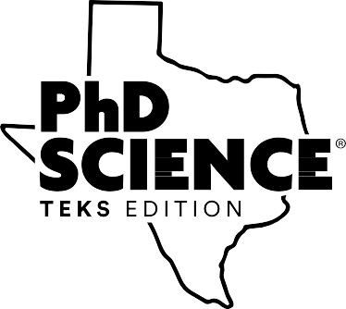
Lesson Foundations
Participant Handout
160.01.01P

[page intentionally left blank]
2020
Copyright © Great Minds PBC


Lesson Foundations
Session Prework
1.
2.
3.
Attend and actively engage in the Curriculum Foundations session. Attend and actively engage in the Module Foundations session.
Read Storyline (Appendix B) of the first module that you will teach, and list different
activities that students engage in throughout the module. Document in the table below.
1
Copyright © Great Minds PBC
Activity
Description

Lesson Foundations
2
Copyright © Great Minds PBC
Activity
Description

Lesson Foundations
Lesson Types
3
Copyright © Great Minds PBC
Type
Notes

Routine Lesson

Introducing Anchor Phenomena

Anchor Model

Anchor Chart

Driving Question Board

Lesson Foundations
4
Copyright © Great Minds PBC
Type
Notes

Knowledge Building Activity

Investigation

Conceptual Checkpoint

Science or Engineering Challenge

Socratic Seminar

End-of-Module Assessment

Lesson Foundations
Implementation
5
Copyright © Great Minds PBC
Step
Notes
Prepare

Plan

Communicate

Preview

Organize

Lesson Foundations
Remote Learning Challenges and Solutions
6
Copyright © Great Minds PBC
Challenge
Solution

Lesson Foundations
Notes
7
Copyright © Great Minds PBC

Lesson Foundations
Session Post-Work
1.
2.
Complete the series culminating exit ticket.
Put your new knowledge into practice.
8
Copyright © Great Minds PBC

Lesson Foundations
Credits
Great Minds® has made every effort to obtain permission for the reprinting of all copyrighted material. If any owner of copyrighted material is not acknowledged herein, please contact Great Minds for proper acknowledgment in all future editions and reprints of this presentation.
Slide 56, iStockPhoto/Getty Images; USFWS/Science Source; Ted Kinsman/Science Source; slide 64, U.S. Air Force photo by Master Sgt. Mark C. Olsen; All other images are the property
of Great Minds.
9
Copyright © Great Minds PBC

Lesson Foundations
Works Cited
Great Minds®. 2020. PhD Science®. Washington, DC: Great Minds. https://greatminds.org/science.
10
Copyright © Great Minds PBC

