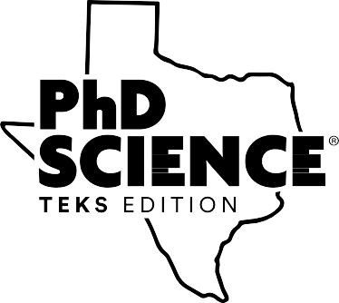
Module Foundations of
PhD Science® TEKS Edition™
Participant Handout
160.01.01P

[page intentionally left blank]
2020
Copyright © Great Minds PBC


Module Foundations of PhD Science® TEKS Edition™
Prework
Read the Introduction section of the Module Overview for the Earth Features module listed below. This can also be found in the front of the module.
Though valueless to the agriculturalist; dreaded and shunned by the emigrant, the miner, and even the adventurous trapper, the Colorado Plateau is to the geologist a paradise. Nowhere on the earth’s surface, so far as we know, are the secrets of its structure so fully revealed as here.
—John Strong Newberry, 1859 (1876, 54)
Throughout the module, students study the formation of the Grand Canyon’s features, the anchor phenomenon, and build an answer to the Essential Question: How did the Grand Canyon’s features form? As they learn about each new concept, students revisit and refine a model to represent the formation of the Grand Canyon’s features. At the end of the module, students use their knowledge of rock layers, weathering and erosion, and patterns of Earth’s features and processes to explain the anchor phenomenon and apply these concepts in new contexts. Through these experiences, students begin to develop the enduring understanding that Earth’s surface features change constantly as a result of natural processes.
Lessons 1 through 5 address the Concept 1 Focus Question: What do Earth’s rock layers reveal? Students begin to identify that the rock layers in the Grand Canyon tell the story of Earth’s past. They observe different features of the Grand Canyon that allow geologists to study the past. Lessons 1 and 2 introduce the anchor phenomenon through pictures of the Grand Canyon and the story of John Wesley Powell, who led two of the most famous Grand Canyon expeditions. Reflecting on this phenomenon, students organize their questions on a driving question board and develop an initial class anchor model to explain the formation
of the Grand Canyon. Students revisit the driving question board and the anchor model throughout the module to build a coherent understanding of the formation of the Grand Canyon’s features. Engaging
in these practices allows students to take an active role in the educational process and gives teachers insight into students’ background knowledge and current understanding of Earth’s features and processes. In Lessons 3 and 4, students study the Grand Canyon’s rock layers and the fossils in them to label the layers oldest to youngest and infer information about past environments. In Lesson 5, students use the text Grand Canyon by Jason Chin (2017) to help explain how the environment of the Grand Canyon changed over time.
Lessons 6 through 11 address the Concept 2 Focus Question: How are Earth’s rock layers uncovered? Students develop the understanding that the processes of breaking rock into smaller pieces (weathering) and moving sediment (erosion) play a role in shaping Earth’s surface. In Lessons 6 and 7, students conduct investigations to explain how one material can break down another material as they develop
an understanding of weathering. Students then construct a landscape in a stream table in Lesson 8, and in Lesson 9 they use the stream table to investigate how weathered rock, or sediment, moves from one place to another as they develop an understanding of erosion. In Lesson 10, students plan and conduct an investigation to study rate of erosion. In Lesson 11, students apply their new knowledge to the anchor
phenomenon by updating the anchor model to explain how weathering and erosion could have formed some of the Grand Canyon’s features.
In Lessons 12 through 17, students apply their knowledge of these concepts in new contexts, building on their current understanding of the Essential Question: How did the Grand Canyon’s features form?
1
Copyright © Great Minds PBC

Module Foundations of PhD Science® TEKS Edition™
Lesson 12 introduces students to the engineering design process through the story of the Wright brothers. Students learn that great engineers strive to improve the human condition through this iterative process.
In Lessons 13 through 16, students design a structure to protect a home from erosion and build prototypes
of their design. In Lesson 17, student groups present their prototypes to the class and summarize their design process, including their struggles and successes.
Lessons 18 through 20 address the Concept 3 Focus Question: How do canyons around the world form? Students use a world relief map to identify global patterns in some of Earth’s features (e.g., mountains, volcanoes) and processes (e.g., earthquakes, volcanic activity). In Lesson 18, students view photographs of other canyons around the world to identify similarities and differences in features found near canyons, including rivers and mountains, and use a world relief map to gather information about global patterns of these features. Students extend this work in Lesson 19 by finding patterns in other Earth features and processes based on photographs of faults and volcanic rock in the Grand Canyon. In Lesson 20, students apply their understanding of global patterns of Earth’s features and processes to the anchor phenomenon by updating the anchor model to show how weathering and erosion by the Colorado River and other processes, such as volcanic eruptions and earthquakes, could have formed some of the features of the Grand Canyon.
Lessons 21 through 24 address the Concept 4 Focus Question: How do humans interact with Earth’s features and processes? Students develop the understanding that humans use natural resources to generate electricity and that their use can impact the environment in different ways. In Lesson 21, students model the Colorado River before investigating the impact of dams on the Colorado River in Lesson 22. Students then analyze maps and use their investigation as evidence to make claims about the effect of adding a dam on a river. In Lesson 23, students read information about the Hoover Dam to determine the different reasons for building dams on a river. Students then investigate energy output from dams in the Colorado River Basin and energy needs for households, identifying that people use more energy than what dams generate. In Lesson 24, students read information from multiple sources about different natural resources humans use to generate energy. Students determine environmental impacts of the use of these resources and classify the natural resources as being either renewable or nonrenewable. Students participate in a Socratic Seminar
on how Earth changes in Lesson 25, revisiting the module questions and synthesizing their understanding. In Lesson 26, students reflect on their study and apply their conceptual understandings in an End-of-Module Assessment. Finally, the class debriefs the End-of-Module Assessment in Lesson 27, giving the teacher and students an opportunity to revisit concepts that need further explanation and to clarify misconceptions.
2
Copyright © Great Minds PBC

Module Foundations of PhD Science® TEKS Edition™

Module Internalization Process
As all modules are content-rich modules, this process can be lengthy and extensive, but the following list identifies starting points to help the process of internalizing a module.
1.
2.
3.
4.
Read the Introduction section of the Module Overview. Read Appendix B: Module Storyline.
Use the Module Map to fill out the Questioning Structure visual aid.
Take the end-of-module assessment. Consider the questions below.
Questions to consider:
▪
▪
▪
What do my students need to know?
How will they be demonstrating their knowledge? How do investigations relate to the knowledge built?
Curriculum components to focus on:
▪
▪
▪
Focus Questions for the driving question board Required anchor model components
Updates to the anchor visuals
3
Copyright © Great Minds PBC

Module Foundations of PhD Science® TEKS Edition™

First Minute Out of Seat
Respond to the following question. Use the remaining space for notes.
What are any current steps you take to prepare to teach a unit?
4
Copyright © Great Minds PBC

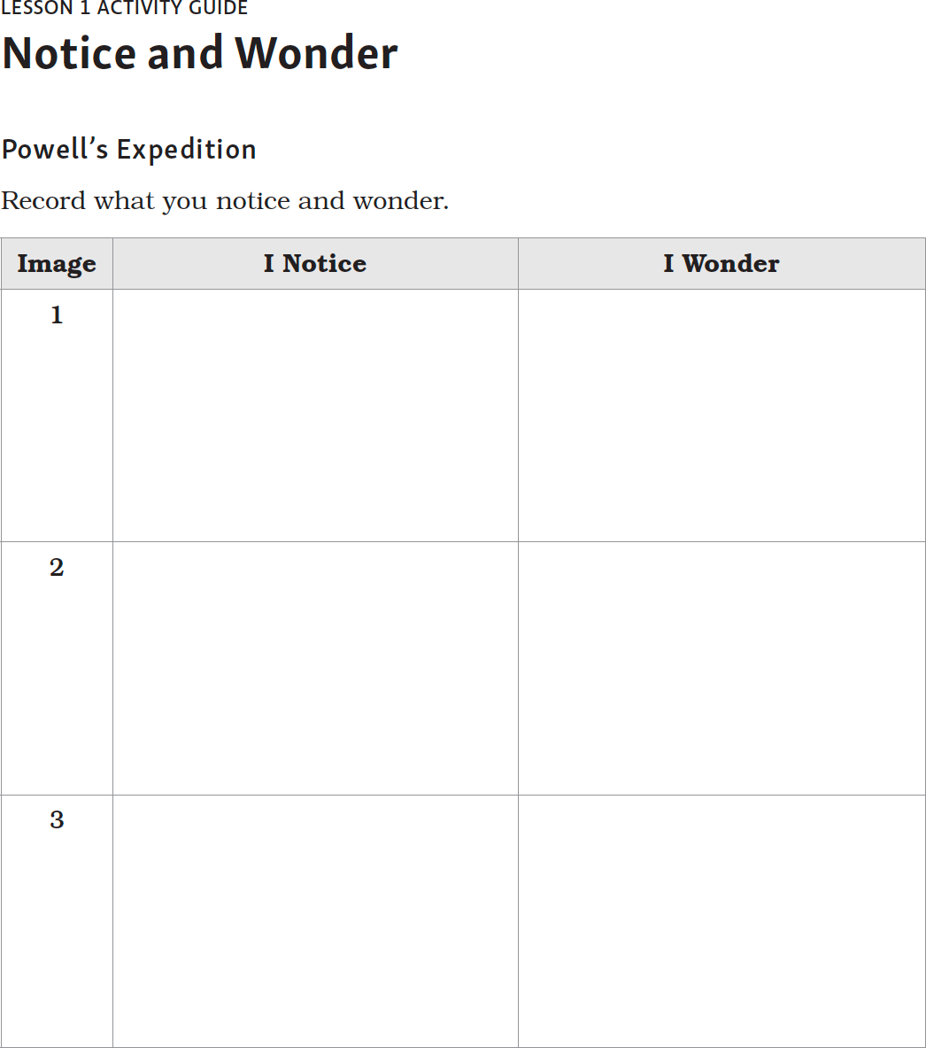
Module Foundations of PhD Science® TEKS Edition™

5
Copyright © Great Minds PBC

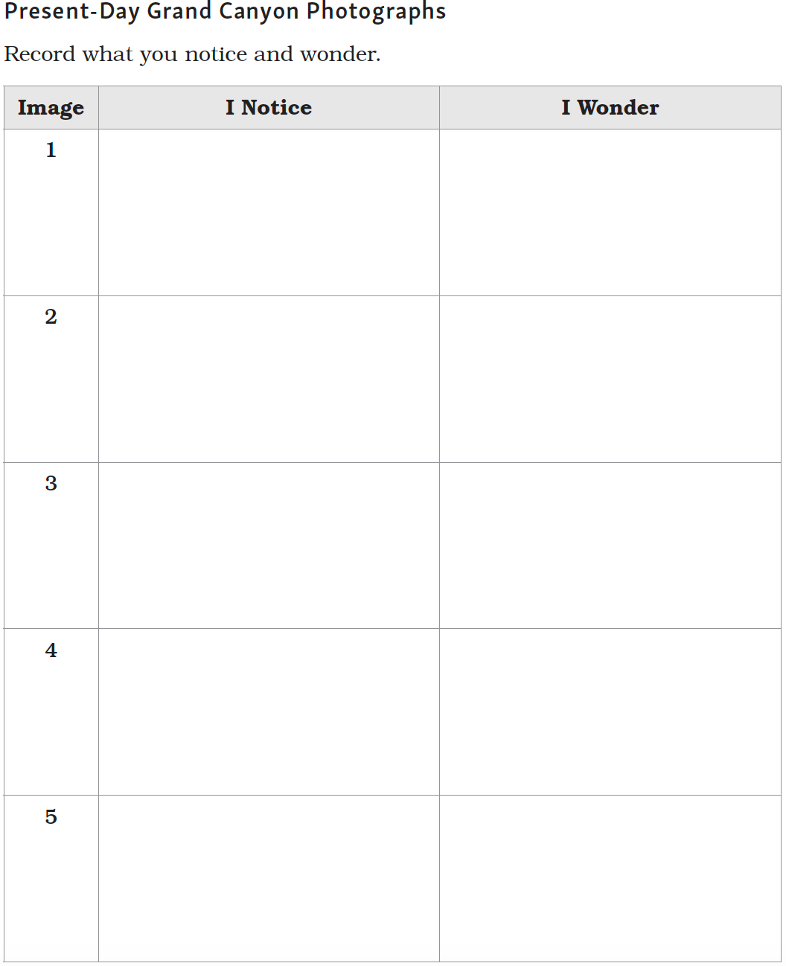
Module Foundations of PhD Science® TEKS Edition™

6
Copyright © Great Minds PBC

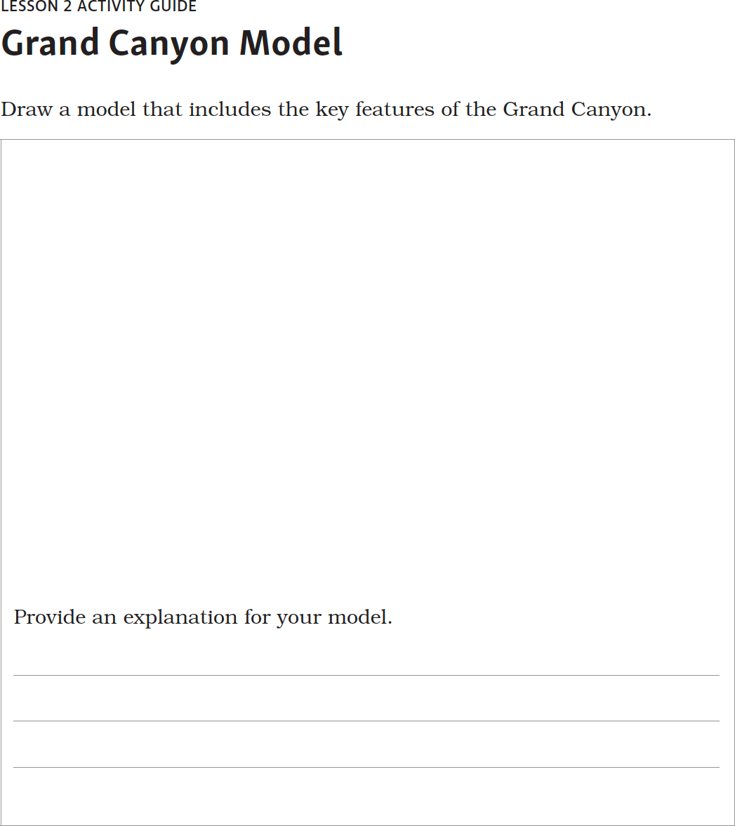
Module Foundations of PhD Science® TEKS Edition™

7
Copyright © Great Minds PBC

Module Foundations of PhD Science® TEKS Edition™

Module Development
Use the space below to note key components and features of module development from start to finish.
Consider thinking about how the anchor visuals working together to build knowledge throughout a module influences your lesson planning and supports you will put in place to assist students in building that knowledge.
8
Copyright © Great Minds PBC

Module Foundations of PhD Science® TEKS Edition™

Post-Work
Use the Module Map to fill out the questioning structure diagram for your first module.
Throughout each module, three types of overarching questions drive student understanding and coherence.
The Essential Question motivates student learning throughout the module. Each concept is framed with a Focus Question that builds coherence and understanding of the Essential Question. Phenomenon
Questions highlight the purpose of lesson sets and tie learning together across lessons. Use the Module Map to fill in the questioning structure. This will develop additional understanding of the scope and sequence
of the module as well as demonstrate how these different questions relate to each other and drive the learning forward.
9
Copyright © Great Minds PBC

Module Foundations of PhD Science® TEKS Edition™

10
Copyright © Great Minds PBC

Module Foundations of PhD Science® TEKS Edition™

Credits
Great Minds® has made every effort to obtain permission for the reprinting of all copyrighted material. If any owner of copyrighted material is not acknowledged herein, please contact Great Minds for proper acknowledgment in all future editions and reprints of this presentation.
11
Copyright © Great Minds PBC

Module Foundations of PhD Science® TEKS Edition™

Works Cited
Great Minds®. 2020. PhD Science®. Washington, DC: Great Minds. https://greatminds.org/science.
12
Copyright © Great Minds PBC

